1️⃣ Classification Model Evaluation Measures
Evaluation metrics tell us how good our classification model is.

1.1 Confusion Matrix (Base of All Metrics)
Actual \ Predicted | Positive | Negative
Positive | TP (True Positive) | FN (False Negative)
Negative | FP (False Positive) | TN (True Negative)

Example: Disease Test (Diabetes)
- Positive (1) → Person has diabetes
- Negative (0) → Person does NOT have diabetes
A model/test predicts whether a person has diabetes.

📋 Confusion Matrix Terms Explained
✅ True Positive (TP)
The model predicts diabetes, and the person actually has diabetes.
✔ Correct detection
📌 “Sick person correctly identified as sick”

❌ False Negative (FN)
The model predicts no diabetes, but the person actually has diabetes.
❗ Dangerous mistake
📌 “Sick person wrongly identified as healthy”

❌ False Positive (FP)
The model predicts diabetes, but the person is actually healthy.
⚠ Unnecessary alarm
📌 “Healthy person wrongly identified as sick”

✅ True Negative (TN)
The model predicts no diabetes, and the person is actually healthy.
✔ Correct rejection
📌 “Healthy person correctly identified as healthy”

1.2 Accuracy
Definition: Percentage of correct predictions.
$$Accuracy=\frac{TP+TN}{TP+TN+FP+FN}$$
Pros
- Simple and intuitive
Cons
- ❌ Misleading for imbalanced datasets
Use when
- Classes are balanced

1.3 Precision
Definition: Out of predicted positives, how many are actually positive.
$$Precision=\frac{TP}{TP+FP}$$
Important when
- False positives are costly
(Spam detection, Fraud detection)

1.4 Recall (Sensitivity / TPR)
Definition: Out of actual positives, how many did we correctly predict.
$$Recall=\frac{TP}{TP+FN}$$
Important when
- False negatives are costly
(Cancer detection, Loan default)

1.5 F1-Score
Definition: Harmonic mean of Precision and Recall.
$$F1=2×\frac{Precision×Recall}{Precision+Recall}$$
Use when
- Dataset is imbalanced
- Need balance between precision and recall

1.6 ROC Curve & AUC
- ROC Curve → TPR vs FPR
- AUC → Probability model ranks positive higher than negative
Interpretation
- AUC = 0.5 → Random model
- AUC = 1.0 → Perfect model
Best for
- Comparing classifiers independent of threshold
ROC-AUC Score | What it tells you
1.0 | Perfect class separation
0.9+ | Excellent model
0.8 – 0.9 | Good model
0.7 – 0.8 | Acceptable
0.5 | No discrimination (random)
< 0.5 | Model is misleading

1.7 Log Loss
Measures confidence of predictions.
$$LogLoss=-\frac{1}{N}∑(ylog⁡p+(1-y)log⁡(1-p))$$Where:
- $y$→ true label (0 or 1)
- $p$→ predicted probability for class 1
- $N$→ number of samples

Scenario | Log Loss
Perfect prediction | 0
Correct but uncertain | Medium
Wrong but uncertain | High
Wrong & confident | Very High

Lower = Better

🔑 Metric Selection Summary
Problem Type | Preferred Metric
Balanced data | Accuracy
Imbalanced data | F1, AUC
Medical diagnosis | Recall
Spam / Fraud | Precision
Probabilistic output | Log Loss

2️⃣ Selecting the Best Classification Model
There is no universal best model (No Free Lunch Theorem).

Factors to Consider
2.1 Nature of Data
Data Type | Suitable Models
Linear | Logistic Regression
Non-linear | Decision Tree, Random Forest
High-dimensional | SVM
Large dataset | XGBoost, LightGBM

2.2 Business Requirement
- Need interpretability → Logistic Regression, Decision Tree
- Need high accuracy → Ensemble models

2.3 Dataset Size
- Small → Naive Bayes, Logistic Regression
- Large → Random Forest, Boosting

2.4 Overfitting Risk
- High risk → Regularized models, ensembles

3️⃣ Cross-Validation
Cross-validation helps check whether a model performs well not just on one split, but across multiple data splits, reducing overfitting and giving a more reliable performance estimate.

Cross-validation evaluates a model by training and testing it on multiple different data splits to ensure stable and unbiased performance.
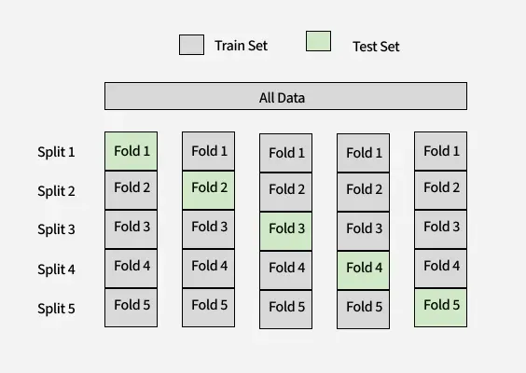
Cross-validation evaluates model generalization performance.

3.1 Why Cross-Validation?
- Single train-test split may be biased
- Uses entire data efficiently

3.2 K-Fold Cross Validation
- Split data into K folds
- Train on K−1 folds
- Test on remaining fold
- Repeat K times
- Average the score
Common values
Choosing the Value of K
The choice of K affects the trade-off between bias and variance:
- Small K (e.g., K =2 or K=5): Faster computation with increased variance in performance estimates.
- Large K (e.g., K =10 or K =n, where n is the size of the dataset): Lower variance but higher computational cost. K =n corresponds to Leave-One-Out Cross Validation (LOOCV).
A standard choice is 10-Fold Cross Validation that is a good trade-off between bias and variance in most situations.

- K = 5 or 10

3.3 Stratified K-Fold
- Maintains class proportion
- Essential for classification
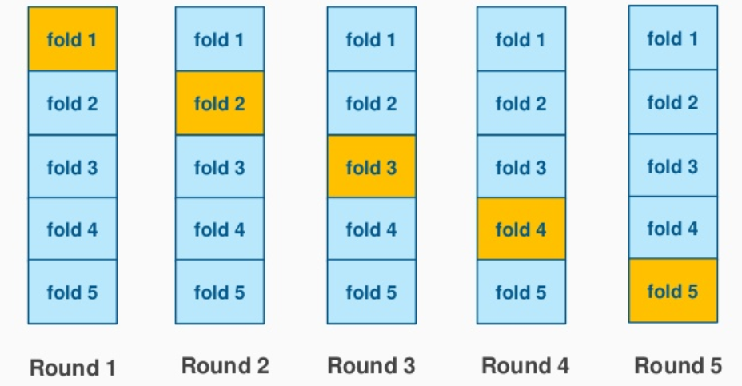

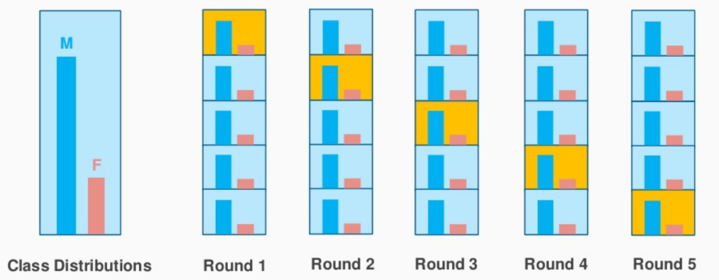

3.4 Leave-One-Out (LOOCV)
- Extreme case of K = N
- Computationally expensive

3.5 Time Series CV
- Preserves temporal order
- No shuffling

🔑 Best Practice
Always use Stratified K-Fold for classification problems

4️⃣ Hyper-Parameter Tuning
Hyperparameters are not learned, they are set manually.

Examples
Model | Hyperparameters
Logistic Regression | C, penalty
SVM | C, kernel, gamma
Random Forest | n_estimators, max_depth
XGBoost | learning_rate, max_depth

4.1 Grid Search
- Exhaustive search
- Slow but accurate
GridSearchCV(model, param_grid, cv=5)

4.2 Random Search
- Random combinations
- Faster than Grid Search

4.3 Bayesian Optimization
- Intelligent search
- Used in production (Optuna, Hyperopt)
- Optuna and Hyperopt are production-grade Python libraries used to perform Bayesian Optimization for hyperparameter tuning.
- They intelligently search for the best hyperparameters without trying every possible combination.

⚠ Avoid Overfitting
- Tune parameters inside cross-validation
- Never tune on test data

5️⃣ Model Comparison
Compare multiple models using same evaluation setup.

Steps
- Same train-test split
- Same cross-validation strategy
- Same evaluation metric
- Compare mean CV scores

Example Comparison Table
Model | CV Accuracy | CV F1
Logistic Regression | 0.85 | 0.82
Random Forest | 0.90 | 0.88
XGBoost | 0.93 | 0.91

6️⃣ Selecting the Best Model (Final Decision)

Final Checklist ✅
1️⃣ Performance
- Highest CV score
- Stable across folds

2️⃣ Generalization
- Similar train and test performance
- No large variance

3️⃣ Business Constraints
- Interpretability
- Prediction latency
- Deployment cost

4️⃣ Robustness
- Handles noise
- Handles missing values

